CITY OF WICHITA FALLS
CLAIM FILING PROCEDURES

To file a claim against the City of Wichita Falls for Compensation of damages to your person or property, sufficient information is required. (City of Wichita Falls Code of Ordinances, Section 2.8)
Any statements or promises made to you concerning your claim by any other city employee or agency are unauthorized and are not binding by the Risk Management or City Attorney’s Office.
A claim can be considered only after it is filed in writing at the office of the City Clerk or the Risk Management office. By filing a claim you agree to allow the City or its agent to inspect your property or investigate the physical injury. Unreasonable refusal of such inspection or investigation will be grounds for denial of your claim.
Filing a claim against the City does not automatically guarantee reimbursement from the City. However, the City examines each claim on an individual basis in determining if reimbursement is legally required.
In order to obtain reimbursement for a claim against the City, you must prove that the City or its employees acted unlawfully or negligently.

ACCEPTANCE OF THIS REPORT BY THE CITY IS NOT AN ADMISSION OF LIABILITY

The following must be provided in letter form prior to the 45th day after the damages you incurred:

- The time, date and exact location of the reported incident.

- As detailed a description as possible stating the nature and extent of the injury or damage. The manner in which the injury or damage occurred including the date, time, place, and a copy of any pictures taken.

- Proof of the amount of the claim by means of either itemized receipts or two itemized estimates (If you are submitting two estimates, claims will not be processed unless they are itemized and provided from two separate agents, companies, or vendors).

- The amount for which the claimant will settle.

- Names and addresses of witnesses, if any, to the incident.

- Police accident report or number, if any.

- Be sure your name, address, email address and telephone number are on your claim.

This claim must be postmarked or hand delivered to the following address within 45 days of the injury or loss:

City Clerk
Memorial Auditorium
1300 7th Street, Room 104
PO Box 1431
Wichita Falls, TX 76307
940-761-7632
Risk-claims@wichitafallstx.gov



This form is being provided to assist you in filing your claim. Providing this form is not an admission nor shall it be construed to be an admission of liability or an acknowledgment of the validity of a claim by the political subdivision. Your claim must be filed and received by the City of Wichita Falls City Clerk’s office no later than 45 days from the date of the incident.

PERSONAL INFORMATION
NAME: |  |  | DATE:
CURRENT ADDRESS: | CITY: | STATE: |  | ZIP:
EMAIL: | CELL PHONE: | HOME PHONE: |  | WORK PHONE:

CLAIM INFORMATION
DATE CLAIM OCCURRED: | TIME: |  | A.M ☐ P.M ☐
LOCATION:

WHAT INJURIES OR DAMAGES ARE YOU CLAIMING?
(attach separate sheet, if needed)

DESCRIBE IN DETAIL HOW DAMAGE OR INJURY OCCURRED:
(Attach Separate sheet, if needed)

WHY DO YOU CLAIM THE CITY OF WICHITA FALLS IS RESPONSIBLE?
(Attach Separate sheet, if needed)

NAME OF CITY EMPLOYEE AND/OR DEPARTMENT involved in the injury or damage

Employee: |  | Department:
Employee: |  | Department:

PERSONAL INJURY
WERE YOU INJURED | DATE OF TREATMENT:
DESCRIBE INJURIES:

NAME AND ADDRESS OF DOCTOR:

ARE YOU PRESENTLY UNDER A DOCTOR’S CARE? | NAME AND ADDRESS OF HOSPITAL:

AUTO DAMAGE
INSURANCE COMPANY: | POLICY # | ARE YOU THE REGISTERED OWNER?  YES ☐ NO ☐
HAVE YOU SUBMITTED A CLAIM TO YOUR CARRIER? YES ☐ NO ☐ | IF YES, WERE YOU PAID?  YES ☐ NO ☐ | IF PAID, WHAT AMOUNT?
MAKE OF VEHICLE | MODEL | COLOR
YEAR | VEHICLE LICENSE NO.

WITNESS TO DAMAGE
NAME | PHONE | ADDRESS
NAME | PHONE | ADDRESS
NAME | PHONE | ADDRESS

READ CAREFULLY
For all accident claim, place on the below diagram name of streets, place of an accident with “X” and show house numbers or distances to street corners. If city vehicle was involved, designate by letter “A” location of City vehicle when you first saw it, and with “B” location of yourself or your vehicle when you first saw the City vehicle: Then for location of City vehicle at time of accident with “A-1” and location of yourself or your vehicle at the time of the accident with “B-1” and the point of impact by “X”. Note: If the diagram below does not fit the situation, attach a proper diagram signed by the claimant.

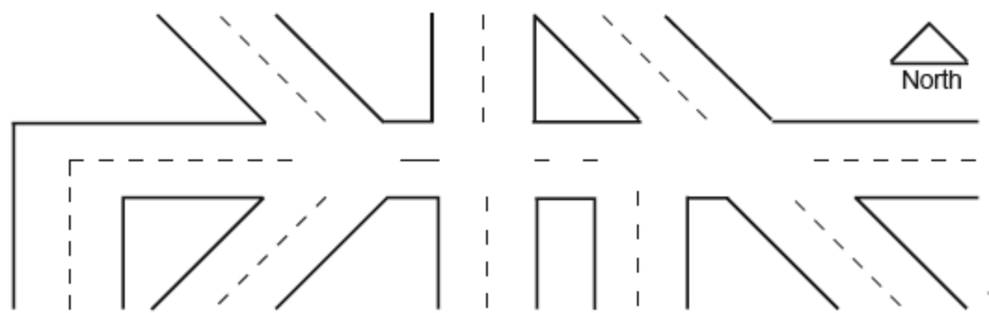

AMOUNT CLAIMED, AS OF THE DATE OF PRESENTATION OF THE CLAIM (attach copies of all documentation including itemized receipts, photographs, (2) repair estimates, medical bills):

Damages Incurred to date (exact)
Property Damage | $
Expenses for medical care (if any) | $
General Damages: | $
Total Damages to Date | $
Specify the TOTAL SUM you claim: | $
Attach a copy of all documentation including receipts, photographs, repair estimates, medical bills, etc., that support the total amount claimed. I HEREBY CERTIFY UNDER PENALTY OF PERJURY, THAT THE FOREGOING FACTS ARE TRUE AND CORRECT TO THE BEST OF MY KNOWLEDGE AND BELIEF. Texas Insurance Fraud Statute (Penal Code, Title 7, Chapter 35)
Signature of Claimant: | Date:

